Sulfonylmids, quinolones, oxazolidones
The research of Paul Ehrlich, the founder of chemotherapy, drug development and medical chemistry in Germany, fueled even more interest in dyes, which are believed to have antibacterial activity. In the Bayer laboratories, they begin the synthesis of azo dyes. In 1932, Gerhard Domagk conducted a scientific study of a red dye called "Prontosil" and discovered that this substance is susceptible to streptococcal infections in mice. However, it was found that the compound is inactive in bacterial culture. Of great interest is the fact that Prontozil is inactive in vitro and active in vivo. As a result of studies conducted by a group of researchers in 1936, the structure-activity relationship of azo dyes was studied and it was established that the N=N bond is destroyed in vivo with the formation of a sulfanilamide structure, which is an active compound. .
This result was confirmed by Fuller's isolation of sulfonamides from the blood and urine of patients receiving Prontozil. Based on these results in 1948. 4500 derivative sulfonamides were synthesized, and only two of them entered clinical practice. Currently, sulfonamides are used in combination with trimethoprim for urinary tract infections.
Sulfanilamide term:
1) Aniline combined sulfanilamides, etc. Sulfanilamide
2) Sulfonamide-forming prodrugs (sulfasalazine)
3) Sulfanilamides without aniline ring (mafenid), antidiabetic sulfanilamides (tolbutamide).
Action mechanisms
Coenzymes of folic acid are synthesized using folic acid, which occurs naturally in the human body. Cell division and synthesis of nucleic acids are impossible without folic acid coenzymes. Bacteria do not use the body's folic acid, which they enter, but synthesize it themselves. Bacteria synthesize folic acid using p-aminobenzoic acid. Antibacterial compounds in the sulfonamide and sulfone structure are competitive inhibitors of the stage of formation of dihydropteroic acid from p-aminobenzoic acid. Trimethoprim inhibits folate reductase, which catalyzes the conversion of dihydrofolic acid to tetrahydrofolic acid in bacteria. Thus, sulfanilamides inhibit the growth and reproduction of bacteria, blocking the biosynthesis of folate coenzymes. Preparations of sulfonamides and trimethoprim have a bacteriostatic effect. Small avidity of trimethoprim to human folate reductase leads to toxic effects.
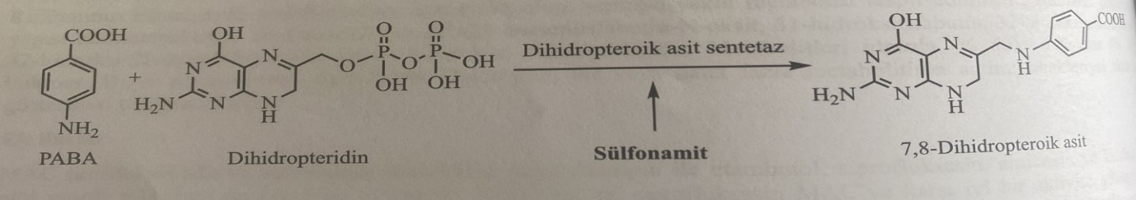
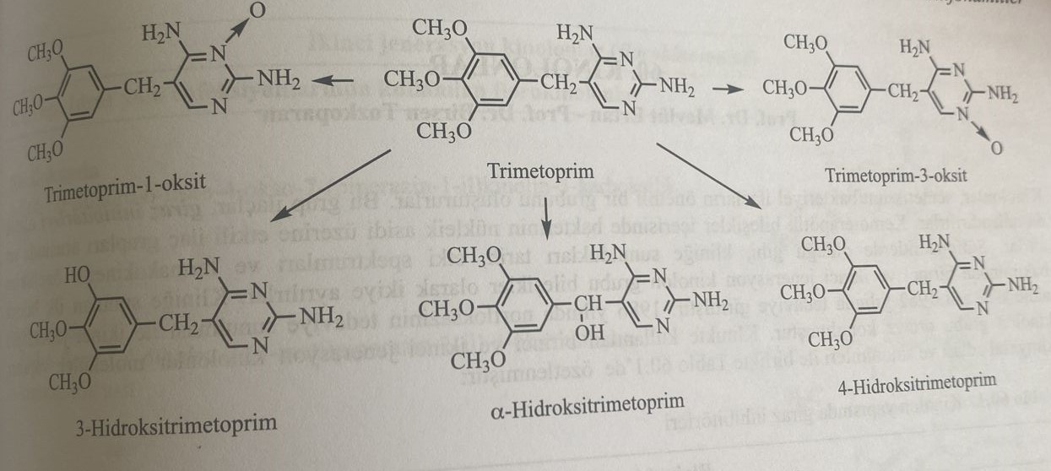

The extensive use of sulfonamides led to the resistance of bacteria. In addition to some mechanisms for the formation of persistence, an increase in the synthesis of p-aminobenzoic acid in bacteria has been established. If the microbe has acquired resistance to one sulfanilamide, resistance to all sulfanilamides will be observed.
Compounds with a sulfonamide structure cause the formation of sulfonamide crystals in the kidneys. Metabolites of sulfonamides and N4 are excreted in the urine. Sulfanilamides are poorly soluble in water. If the pH of the medium is not higher than rka (10.4), the water-soluble ion form is formed very little. The pH of urine is about 6, and in this case sulfanilamides are insoluble in the kidneys. If ph is equal to pka, the ionized/non-ionized ratio is 1:1.
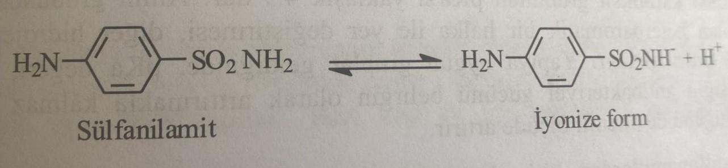
To increase the solubility of sulfonamides in urine:
1) increase diuresis
2) Increase urine pH
3) Preparation of sulfanilamide with a pH close to the pH of urine.
4) Use a mixture of sulphamilamides to achieve an adequate dose
In derivatives of sulfonamides with a heterocyclic ring fused to the N1-position, the electroacceptor property of the heterocyclic ring leads to a low value of pka and an increase in ionization. Thus, the value of pka decreases due to the removal of the H+ ion from the molecule.
It was found that mixtures of sulfonamides and trimethoprim-sulfonamides cause severe toxicity. Side effects are observed: Stevens-Johnson syndrome, skin rash, allergic myocarditis, photosensitivity. In addition, hematological side effects such as hemolytic anemia, agranulocytosis and aplastic anemia are observed.
Unlike poorly absorbed sulfonamides, used in ulcerative colitis, to restore bacterial microflora and in superficial burn preparations, the mixture of sulfonamide + trimethoprim is well absorbed. Sulfanilamides bind well to plasma proteins. Combining the drug with proteins leads to the loss of antibacterial effect. However, since the combination with proteins is reversible, the drug shows its effect again. Basically, lipophilicity increases at a physiological pH value, which increases protein binding. As a result of the study of this binding reaction, it was established that the N1 position of the sulfonamide structure is very important for lipophilicity and protein binding. At the same time, N4-acetate metabolites of sulfonamides are more lipophilic than other sulfonamides, and, therefore, they have the ability to bind to a large number of proteins. Sulfanilamides are removed from the body practically unchanged, with the exception of N4-acetate and glucuronides. For example, sulfonamides are metabolized in the liver with the formation of an N4-acetyl derivative.
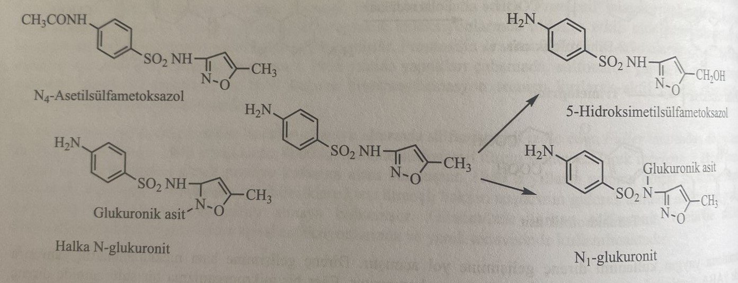
Structure-activity relationships
Sulfonamides and p-aminobenzoic acid are structurally similar substances, the two molecules differ from each other in the presence of a carboxyl group in p-aminobenzoic acid and a sulfanilamide group in sulfanilamide. As a result of the strong electron acceptor property of the SO2 group attached to the aromatic ring, the nitrogen atom in the molecule is partially positively charged. This situation increases the mobility of the hydrogen atom attached to nitrogen, and causes this functional group to acquire slightly acidic (pka=10.4) properties. РКА of the carboxyl group of p-aminobenzoic acid is about 4.9. Replacing one of the hydrogen atoms in the amino group with a heterocyclic ring, which is an electron acceptor, increases the acidity of the second hydrogen and the activity of the molecule. As for structural groups, the value of pka is close to the value of p-aminobenzoic acid. This increases the antibacterial effect and water solubility of the compound.
The pka value of sulfisoxazole, which is used until now, is about 5. The low solubility in water of the first discovered sulfonamides led to crystallization in the urine (crystalluria) and kidney damage. Because such compounds are not ionized at urine pH. When using some sulfonamides, it is recommended to drink plenty of water to prevent crystalluria. Because these compounds are in the form of partially ionizable sodium salts and are soluble in urine pH.
The structure-activity relationship in sulfonamides is as follows:
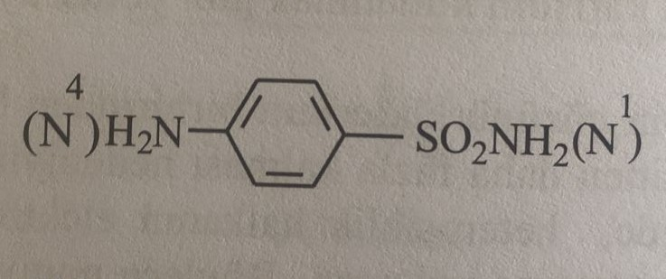
1) Amino- and sulfonyl groups attached to the benzene ring must be in para-position to each other.
2) A functional group should not be attached to the amino group or groups that can be easily separated in vivo should be attached.
3) The introduction of other rings instead of the benzene ring or the addition of other groups to the benzene ring leads to a decrease or loss of activity.
4) Replacement of sulfamoyl group with 4-aminobenzenesulfonyl group does not change the activity, but replacement with such groups as amido, 4-aminobenzoyl causes a decrease or loss of activity.
5) The combination of one group in the N1 position leads to the formation of active compounds with altered pharmacokinetic properties, and the combination of two functional groups in the N1 position leads to the formation of mainly inactive compounds.
In this case, it can be noted that p-aminobenzenesulfonyl group is the main activity. State N1 also provides activation. Structural differences between sulfonamides used in clinical practice are mainly related to the addition of various heterocyclic aromatic rings and acyl groups to the nitrogen atom (N1) of sulfonamides. These changes lead to changes in physico-chemical and pharmacokinetic properties.
Classification
When classifying sulfonamides, such parameters as chemical structure, duration of action, spectrum of action and pharmacotherapeutic group are taken into account.
1) Systemic sulfonamides
а) short action
b) moderately effective
c) long-acting
2) Sulfanilamides, used in gastro-intestinal infections
3) Sulfanilamides, used in ophthalmological infections
4) Sulfanilamides, used in urinary infections.
5) Sulfanilamides, used in the treatment of burns.
6) Sulfanilamides, used in vaginal infections.
Systemic sulfanilamides
Short-acting drugs
They are quickly absorbed and excreted from the body. The elimination period is approximately 4-7 hours. These drugs are used for systemic infections. The most important compounds of this group are: sulfacitin, sulfamethizol, sulfisoxazole, sulfamethazine, sulfacetamide, sulfachlorpyridazine, sulfapyridine, sulfetidol, sulfamerazine, sulfamoxol, sulfaproxilin, sulfathiazole, and sulfisomidine.
Drugs of average efficiency
They are absorbed more slowly and removed from the body more slowly than the short-acting group. The half-life period is about 10-12 hours. The most important compounds of this group are: sulfamethoxazole, sulfadiazine and sulfaphenazole. Some derivatives of sulfonamides of short and medium action are shown in the table.
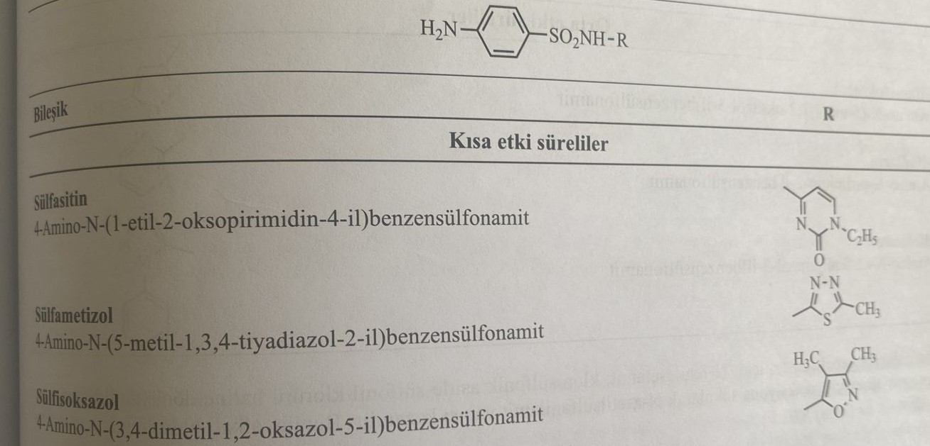
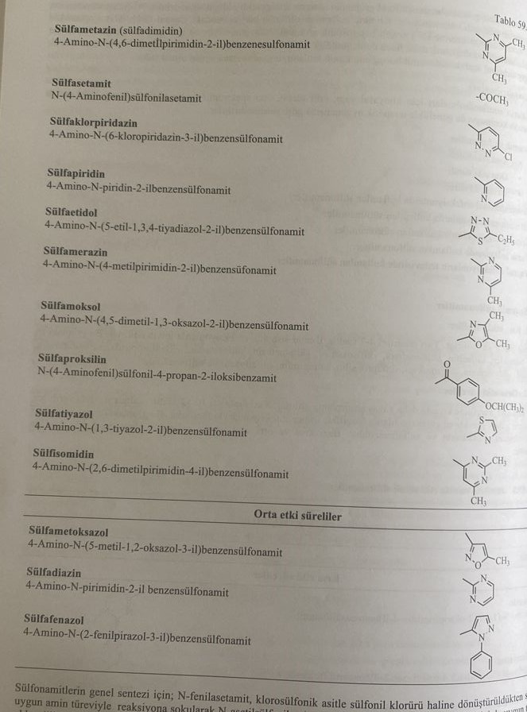
For the general synthesis of sulfonamides, N-phenylacetamide is converted into sulfonyl chloride under the influence of chlorosulfonic acid, and N-acetylsulfanilamide is obtained by reacting with the corresponding amide derivative. Hydrolysis of this in an alkaline medium gives the corresponding derivative.
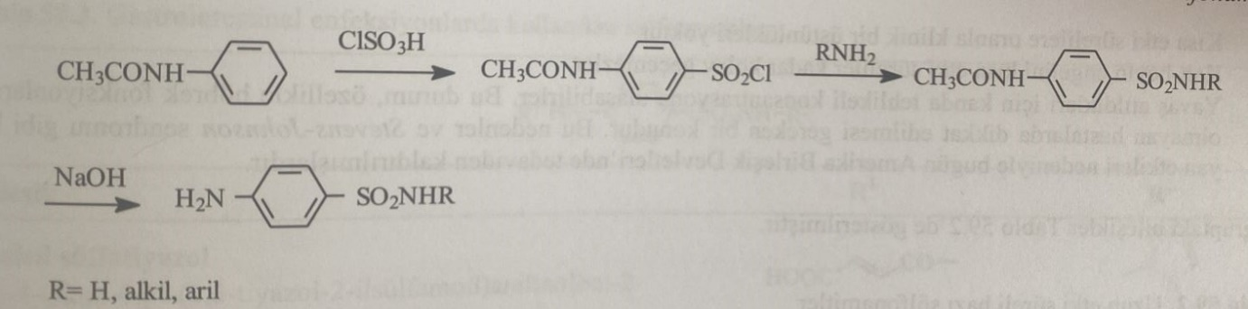
For the synthesis of sulfachlorpyridazine, sulfanilamide is introduced into the reaction with 3,6-dichloropyridazine.
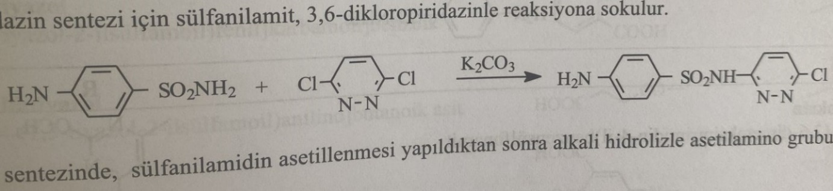
After sulfanilamide is acetylated in the synthesis of sulfacetamide, it undergoes hydrolysis in an alkaline medium. Thus, the acetylamine group is converted into an amine form.
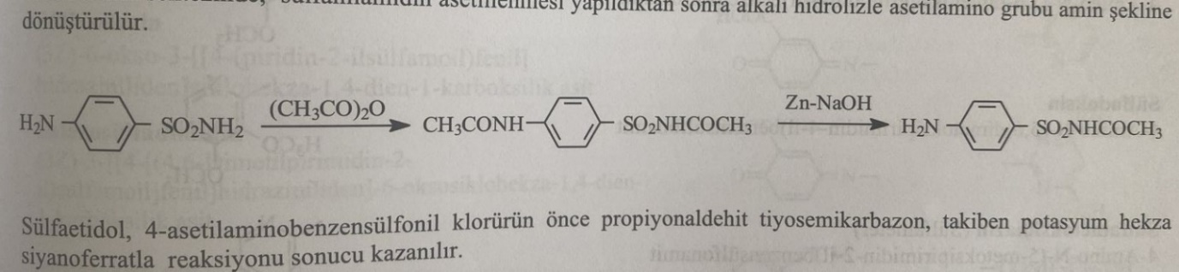
Sulfaetidol is obtained by reacting 4-acetylaminobenzenesulfonyl chloride first with propionaldehyde thiosemicarbazone, followed by potassium hexacyanoferrate.
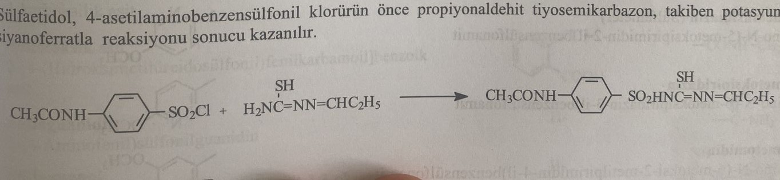
For the synthesis of sulfaproxil, 4-acetylaminobenzenesulfonamide is first reacted with 4-(isopropoxy)benzoyl chloride. The preparation is obtained as a result of the hydrolysis of the treated product in an alkaline environment.
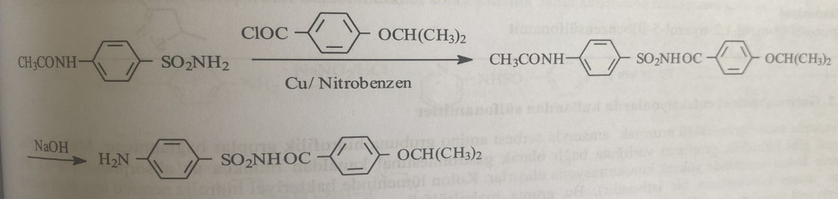
Long acting preparations
These derivatives are absorbed quickly, and their elimination from the body is slow. Half-life is 35-40 hours. The half-life of sulfalen and sulfadoxine is 65 and 179 hours, respectively. Long-acting sulfonamides are prescribed once or twice a day. Their slow elimination is related to their high lipophilicity. Groups providing lipophilicity are functional groups such as small chain alkyl (methyl and especially ethyl) and alkoxy (methoxy and ethoxy) and phenyl. These compounds have the following properties:
1) There are no clinical advantages compared to short-acting drugs.
2) They cannot cross the hematoencephalic barrier as well as short-term drugs.
3) Because they are slowly excreted, they can accumulate in dangerous concentrations in the blood. This situation is even more dangerous, especially in case of kidney failure.
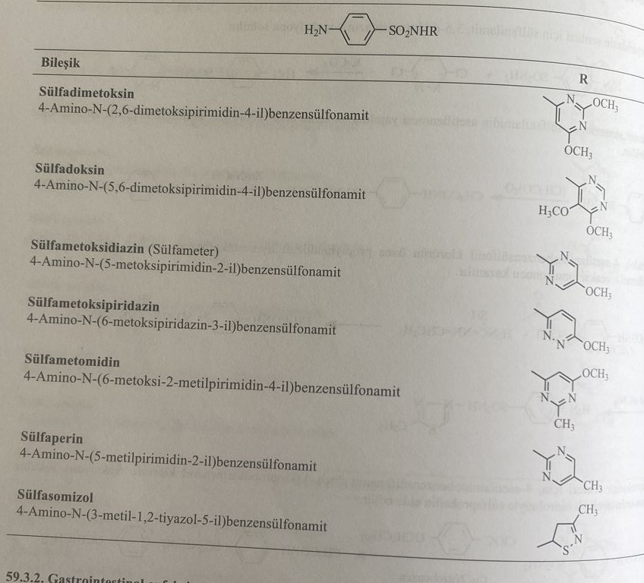
Sulfonamides used in gastrointestinal infections
In order to increase the solubility of these compounds in water, hydrophilic groups were attached to the free amine group. Due to the incorporation of hydrophilic groups such as maleyl, phthalyl, and succinyl into the molecule, the drugs are hardly absorbed from the gastrointestinal tract. Therefore, they accumulate in high concentration in the large intestine. As a result of bacterial hydrolysis in the large intestine, drugs are converted into the main sulfonamide structure (sulfasalazine is an exception). This group includes sulfathiazole derivatives such as maleylsulfathiazole, phthalylsulfathiazole, succinylsulfathiazole, and compounds such as sulfasalazine, salazosulfadimidine, sulfaguanidine, sulfaguanol, and sulfoxylic acid. Sulfasalazine is most commonly used in clinical practice.
For the synthesis of sulfathiazole derivatives such as maleylsulfathiazole, phthalylsulfathiazole, and succinylsulfathiazole, sulfathiazole is reacted with malonic anhydride, phthalic anhydride, and succinic anhydride, respectively.
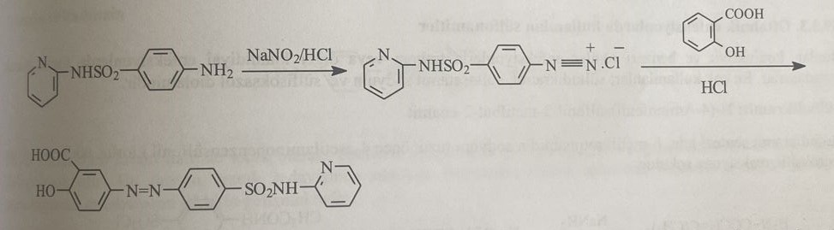
A smaller proportion of sulfasalazine (about 12%) is absorbed. The rest enters the large intestine and is converted into sulfapyridine and 3-aminosalicylic acid by the bacteria there. Sulfapyridine is almost well absorbed. Sulfapyridine, which reaches a high blood concentration, causes the formation of side effects of the drug. Sulfasalazine is used in the treatment of ulcerative colitis.
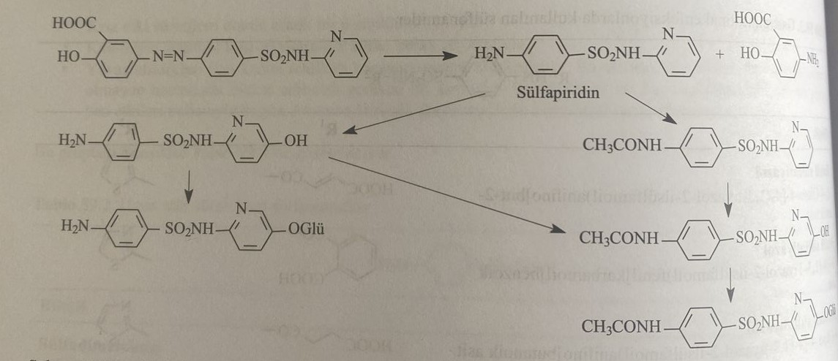
Synthesis of salazosulfadimidine proceeds similarly to sulfasalazine. For the synthesis of sulfaguanidine, sulfanilamide is heated with guanidine carbonate.
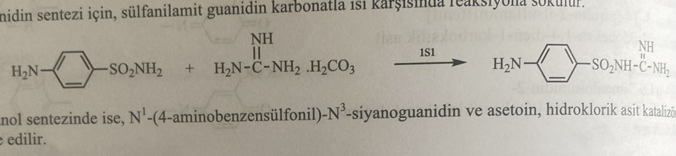
N1-(4-aminobenzenesulfonyl)-N3-cyanoguanidine is introduced into the reaction with acetoin during the synthesis of sulphaguanol. The reaction is catalyzed by hydrochloric acid.
For the synthesis of sulfoxylic acid, 4-aminobenzenesulfonyl acid is subjected to interaction with phthalic anhydride in an alkaline medium. The product reacts with formaldehyde.
Sulfanilamides, used in ophthalmological infections
They are mainly used to treat conjunctivitis, trachoma and other chlamydial infections. The most commonly used drugs are sulfadikramide, sodium sulfacetamide, and sulfisoxazolediolamine.
Sulfadicramide: N-(4-aminophenyl)sulfonyl-3-methylbut-2-enamide
For the synthesis of sulfadikramide, the sodium salt of β-methylcrotanamide is first introduced into the reaction with 4-acetylaminobenzenesulfonyl chloride, and then with sodium hydroxide.
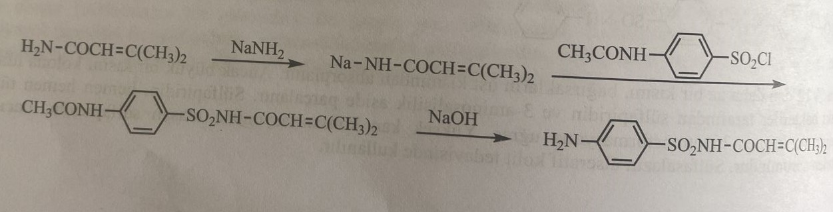
Sulfacetamide sodium: Sodium acetyl-(4-aminophenyl)sulfonylazanide
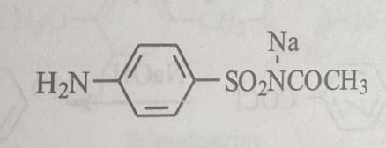
The compound is obtained by reacting sulfacetamide with sodium hydroxide. Thanks to the good solubility of sodium salt at physiological pH (7.4), the drug is prescribed for ophthalmological infections.
Sulfanilamides, used in urinary tract infections
Sulfanilamides of this group are used as antibacterial agents for urinary tract infections, as they have such properties as good absorption, slow excretion from the kidneys, and accumulation in the urinary tract. For this purpose, they use sulfourea, sulfacetamide, sulfacitin, sulfadiazine, sulfadimethoxine, sulfaetidol, sulfameter, sulfamethazine, sulfamethizol, sulfamethoxazole, sulfamethoxypyridazine, sulfaphenazole, sulfisomidine, and sulfioxazole. Sulfacitin, sulfamethoxazole, sulfamethizol and sulfioxazole are among them relatively reliable preparations. Because these drugs dissolve well in urine ph.
Sulfaurea: 4-aminobenzenesulfonylacetic acid
Sulfacarbamide is obtained by hydrolysis of the product formed by the interaction of 4-acetylaminobenzenesulfonamide with potassium cyanate in an alkaline environment.
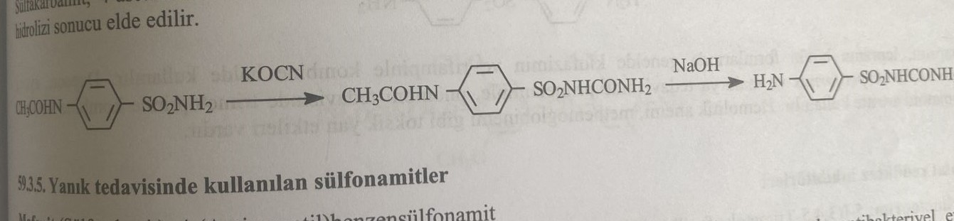
Sulfonamides used in burn treatment
Mafenide (Sulfatolamide) : 4-(Aminomethyl)benzenesulfonamide
Since it is not a true sulfonamide derivative, it is not inhibited by p-aminobenzoic acid. Therefore, the mechanism of action of the drug differs from other sulfonamide drugs. The compound is partially effective against Clostridium welchii. Even during the second world war, it was used in the German army to treat burns. It is not used orally. It is used to treat infected burns.
For the synthesis of the compound, N-benzylacetamide is first reacted with chlorosulfonic acid and then with ammonia to obtain 4-(acetamidomethyl)benzenesulfonamide. As a result of the reaction of this product with sodium hydroxide, mafenide is obtained.
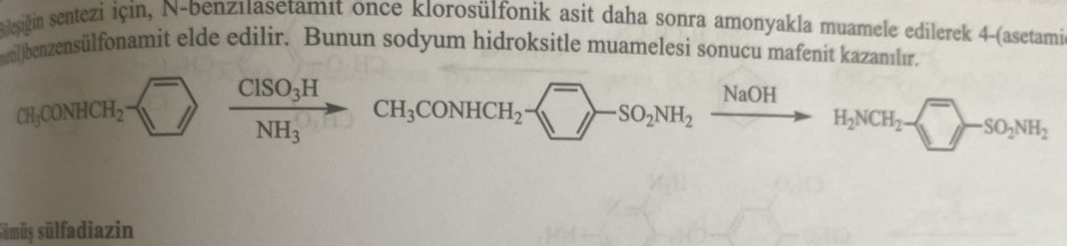
Silver sulfadiazine
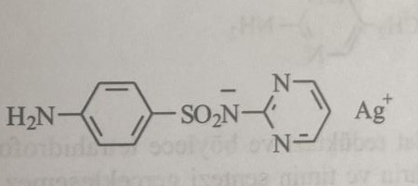
In the form of a water-soluble cream, it is used against infections caused by Pseudomonas species.
Preparations used in the treatment of vaginal infections
It is used for infections caused by Candida albicans and Trichomonas vaginalis.
Sulfabenzamide: N-(4-aminophenyl)sulfonylbenzamide
The reaction of sulfanilamide with benzoyl chloride is used for the synthesis of the compound.
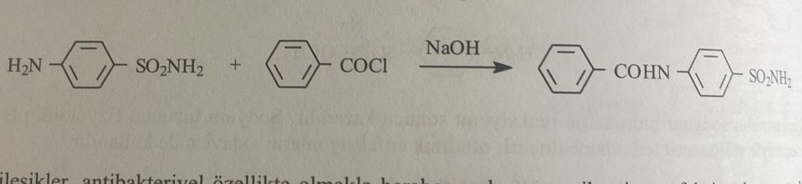
Sulfone
The compounds of this group have an antibacterial effect, and are also used in malaria and rickettsial infections. They are less effective than sulfonamides. p-aminobenzoic acid inhibits the action of sulfonoids similar to sulfonamides. Despite the discovery of various sulfones used in the treatment of leprosy, only dapsone is used from this group.
Folate reductase inhibitor
Trimethoprim: 5-[(3,4,5-trimethoxyphenyl)methyl]pyrimidine-2,4-diamine
For the synthesis of trimethoprim, the product of the reaction of 3,4,5-trimethoxybenzaldehyde with sodium enoxide is obtained as a result of the interaction of 3-anilino-2-(3,4,5-trimethoxybenzyl)acrylonitrile, which is formed from the reaction of 3-anilinepropionitrile with guanidine.
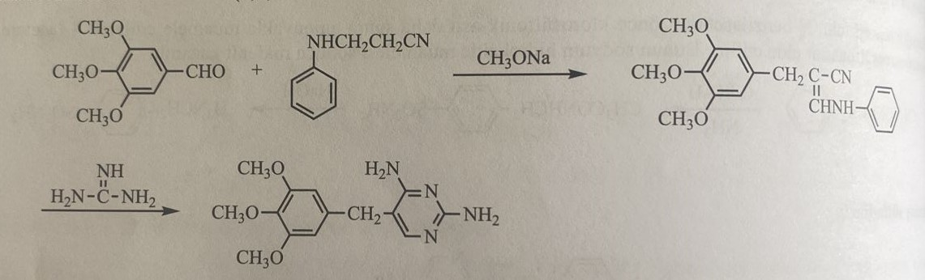
Trimethoprim inhibits dihydrofolate reductase and, thus, the formation of tetrahydrofolic acid in sensitive bacteria. Thus, the synthesis of purines and thymine, necessary for cell division, does not occur. The spectrum of action of trimethoprim extends to various gram(+) and gram(-) bacteria. At the same time, monotherapy may cause resistance to trimethoprim. When used orally, the drug is well absorbed and easily distributed in the tissues. The elimination period is 10 hours. However, the combination with moderately effective sulfonamides has the same mechanism of action as trimethoprim. In the combination of trimethoprim + sulfamine, the metabolism of folic acid is blocked from two different points and a synergistic effect occurs. The synergistic effect of the combination of sulfanilamide+trimethoprim is 20:1. Most of trimethoprim is excreted from the body unchanged. Trimethoprim is metabolized in the liver with the formation of the following compounds.
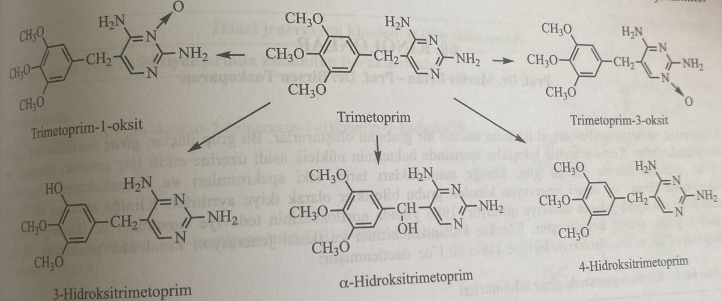
Tetroxoprim: 5-[[3,5-Dimethoxy-4-(2-methoxyethoxy)phenyl]pyrimidine-2,4-diamine
Synthesized as an analogue of trimethoprim. In combination with sulfadiazine, it is used in infectious diseases of the urinary and respiratory tracts. The synthesis of the compound is similar to that of trimethoprim.
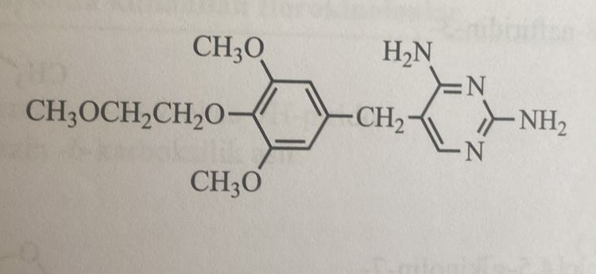
Quinolones
Quinolones make up the main group of synthetic antibacterial preparations. This group of drugs is also called gyrase inhibitors. Among chemotherapeutic compounds, they belong to the group of inhibitors of the synthesis of bacterial nucleic acids. Like sulfanilamides, these drugs are divided into quinolones of the first and second generation depending on the date of introduction, spectrum of action and pharmacokinetic properties. Nalidixic acid was the first compound that entered clinical practice in 1962. The introduction of norfloxacin into clinical practice in 1986. It marked the beginning of the second generation of quinolones. First and second generation quinolones used in medical practice are presented in the table below.
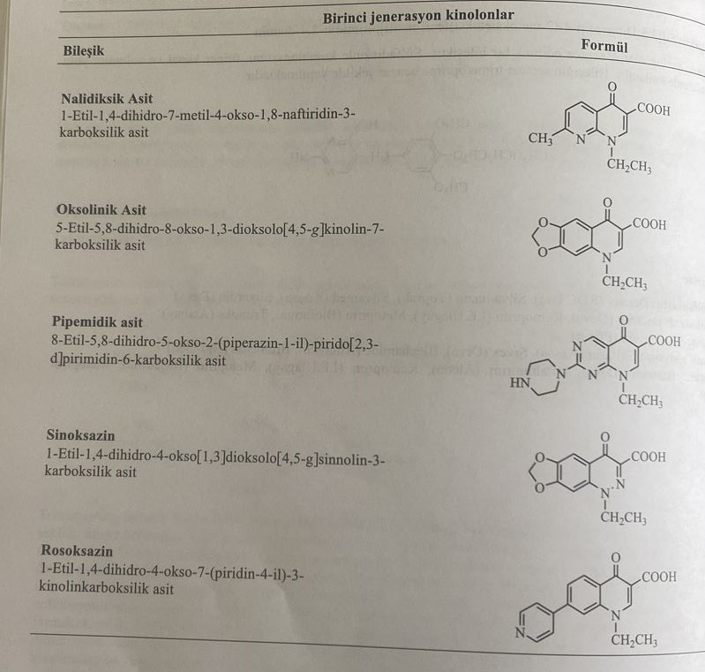
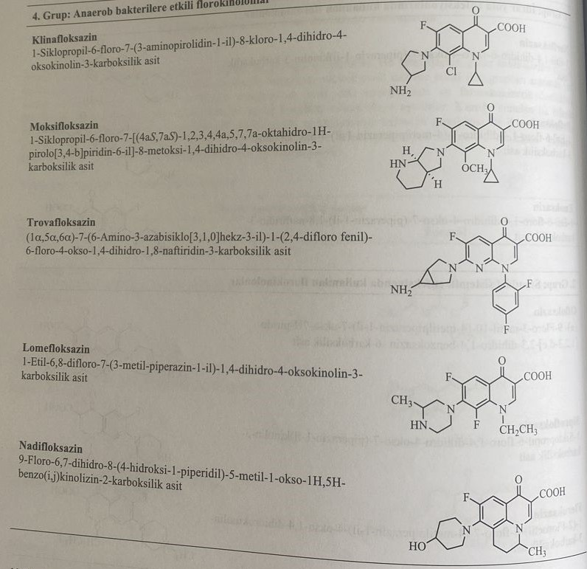
Until the discovery by Lesher in 1962. The antibacterial effect of nalidixic acid 7-chloro-1-ethyl-4-oxo-1,4-dihydroxyquinoline-3-carboxylic acid, which was used in the treatment of plasmodia in 1945, was noticed, but not the antimalarial effect.
In studies carried out by N. Barton and his colleagues in 1960, received certain information about antibacterial preparations. In the synthesis of chloroquine, 7-chloro-4-oxo-1,4-dihydroxyquinoline-3-carboxylic acid was obtained as an intermediate product as a result of the interaction of m-chloroaniline with the diester of alkoxycarbonylmaleic acid. The antibacterial effect of this derivative is proven.
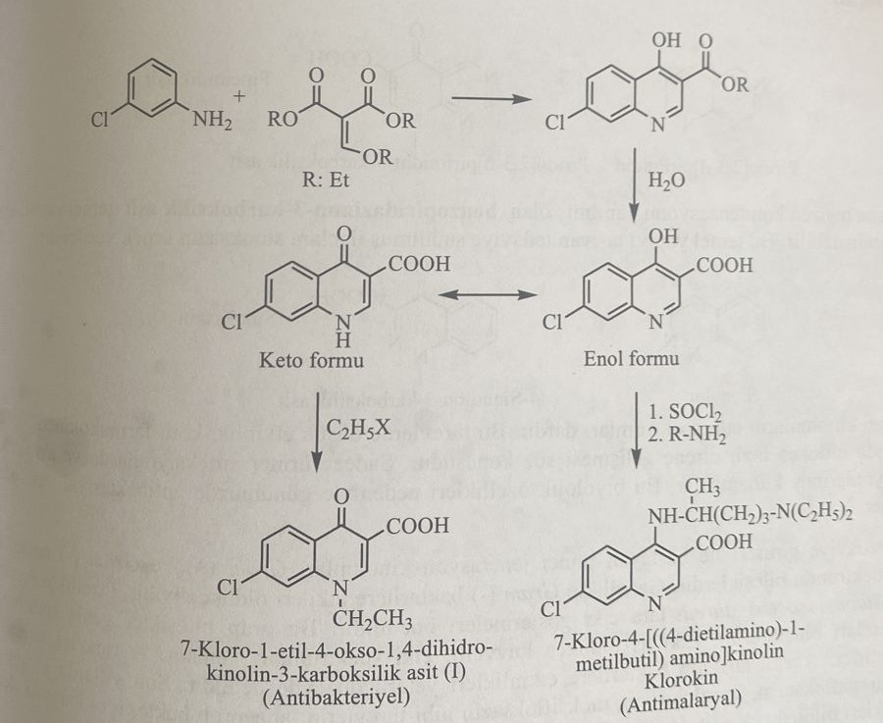
1-Alkyl subunit-1,4-dihydro-4-pyridone-3-carboxylic acid is the basic structure of quinolones used until now in clinical practice. This structure forms the main group of pharmacophore inhibitors of gyrase. All antibacterial preparations based on quinolones contain aromatic and heterocyclic groups condensed in positions C-5 and C-6 in this structure of the pharmacophore.
The compounds are named after the functional groups merged with the structure of the 1-alkyl subunit-1,4-dihydro-4-pyridone-3-carboxylic acid. Compounds with benzene condensation are called derivatives of 4-quinoline-3-carboxylic acid. The main ring is a 1,4-dihydroxyquinoline ring.
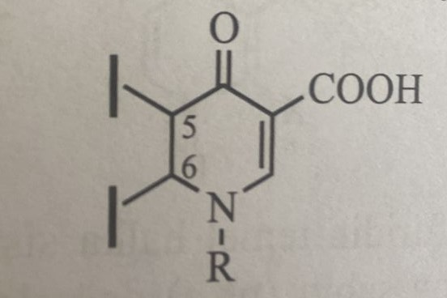
Compounds with pyridine condensation have the structure 4-naphthyridone-3-carboxylic acid. They are also called 1,8-naphthyridine derivatives. This group includes nalidixin acid, enoxacin, trovafloxacin.
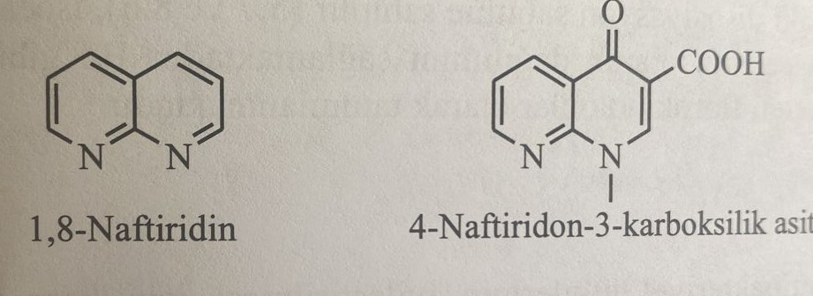
Compounds containing pyrimidine condensations have the structure pyrido[2,3-d]pyrimidine-6-carboxylic acid. Pipemidine acid belongs to this group.
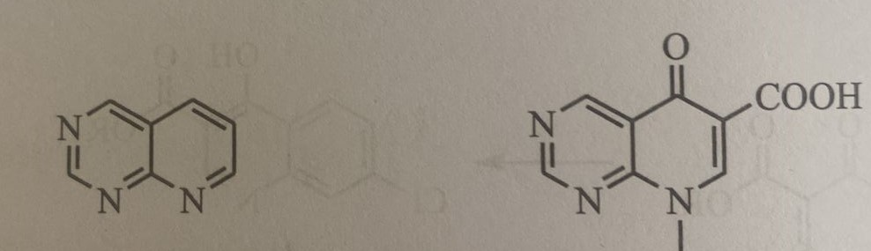
Compounds formed as a result of benzene condensation on the pyridazine ring have the structure of benzopyridazinone-3-carboxylic acid. These are called cinnoline derivatives. Sinoxacin belongs to this group.
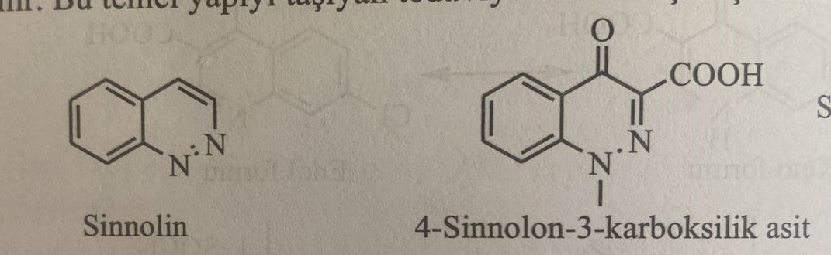
First-generation quinolones have a narrow spectrum of action. Weak activity is observed in these derivatives. They are mainly used in urinary tract infections.
The discovery of norfloxacin led to the second generation. The drug is active against gram(+) and gram(-) bacteria. More sensitivity is observed mainly against gram(-) bacteria. It is especially used against Pseudomonas aeruginosa and Staphylococcus aureus infections. Its effects are quite strong and the spectrum of effects is wide. At the same time, it has good pharmacokinetic properties. Drugs such as trovafloxacin, grepafloxacin, sparfloxacin and moxifloxacin, which have been included in medical practice in recent years, show strong activity against anaerobic infections. Moxifloxacin is widely used among them.
First and second generation quinolones are concentrated in 3 chemical structures.
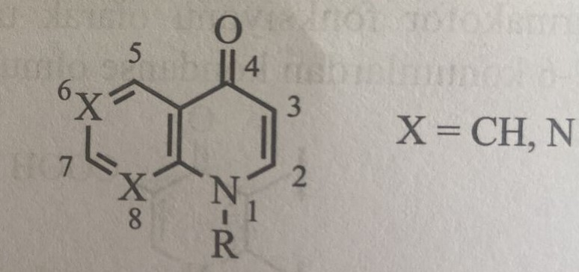
1) Nalidixic acid and analogs: compounds containing a 1,8-naphthyridinic ring, have a high dissociation constant (pka) and form an amphiphilic anion at biological pH (рН=7.4). This group of compounds contains a basic ring similar to piperazine. Pharmacokinetic properties are quite bad.
2) derivatives of 6-fluoro-7-piperazinyl-4-quinolone-3-carboxylic acid: derivatives of 1,8-naphthridin. In the third position there is a carboxyl group, and in the seventh position is a double or triple amino group. A zwitter (hybrid) ion is formed between the carboxyl group and the amino group. They have more lipophilic properties than pipemidine acid. These compounds are called fluoroquinolones. In this group of compounds, there is a certain distance between the protonated nitrogen cation and the carboxylate anion, such as piperazine. These compounds are systemic antibacterial agents. Pharmacokinetic properties are sufficiently good.
3) Hydrophilic derivatives of pyridopyrimidine-6-carboxylic acids: piperazinyl is added in the second position. In the body, they form twitter-ions. For example, the pyrimidine ring in the pipemidine acid molecule has two dissociation constants. Isoelectric junction point 7.1.
Relationship structure-activity
Some modifications were made to improve the antibacterial action of quinolone-3-carboxylic acid derivatives. The spectrum of antibacterial action and pharmacokinetic properties of this group of compounds are presented below.
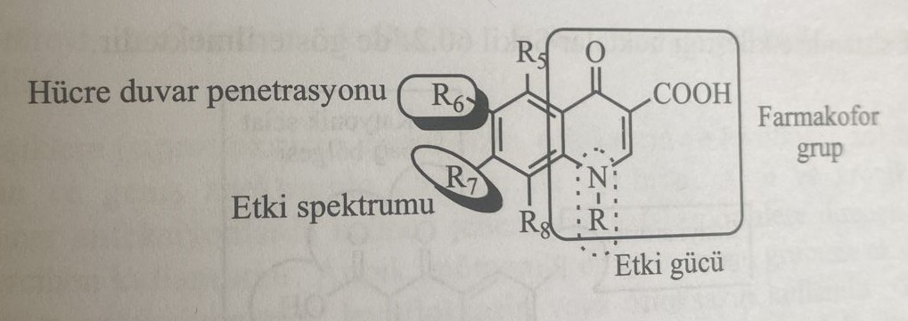
1) The presence of the structure of 1,4-dihydro-3-carboxy-4-pyridone is necessary for activity. The presence of a carboxyl group in the third position and a ketone group in the fourth position play a key role in binding to the DNA/DNA-gyrase enzyme system.
2) Restoration of the double bond between C2 and C3 and the carbonyl group in the fourth position leads to a loss of activity.
3) Adding a fluorine atom to the sixth position increases the lipophilic properties of the drug. Thus, the preparation more easily overcomes the lipid barrier, penetrates faster into the cytoplasm of bacteria. Antibacterial activity increases. At the same time, optimal lipophilicity increases the concentration of the drug in the infected area of the human body.
4) The presence of a zwitter-ionic structure and the corresponding lipophilic properties of compounds increase their binding to the active region of DNA gyrase and topoisomerase IV enzymes. Less lipophilic amphipathic compounds, such as nalidixic acid, have very low avidity of enzymes.
5) The structural method that explains the activity of fluoroquinolones of the second generation against blue infection is the lipophilicity of the molecule and the structure of the zwitter-ion. Because gram(-) bacteria have greater lipophilicity than gram(+) bacteria.
6) Adding a second fluorine atom to С8 increases the absorption and half-life of the drug. But at the same time, it increases the photosensitivity caused by the drug. But the addition of methoxy group to C8 reduces photosensitivity. (eg moxifloxacin)
7) The presence of a heterocyclic ring in the C7 position increases the spectrum of activity against gram(-) bacteria. At the same time, the most important groups that create an optimal effect are the piperazine (ciprofloxacin) and pyrrolidine (moxifloxacin) rings. However, the addition of the piperazinyl group in the seventh position has additional effects, as it increases the binding of the compound to the receptors of γ-amino fatty acids in the CNS. The addition of an alkyl radical to the nitrogen atom of piperazine reduces binding to receptors of g-amino fatty acids.
8) Adding an alkyl radical to the first position of the compound forms a pharmacophore activity. In the first case, the presence of branching is the main condition for the preservation of the molecule in the active ketoform. In the enol form of 4-hydroxypyridine, 4-hydroxyquinoline derivatives do not have the same antibacterial effect as chloroquine. In the case of quinolones, ketoform is the basis of antibacterial activity.
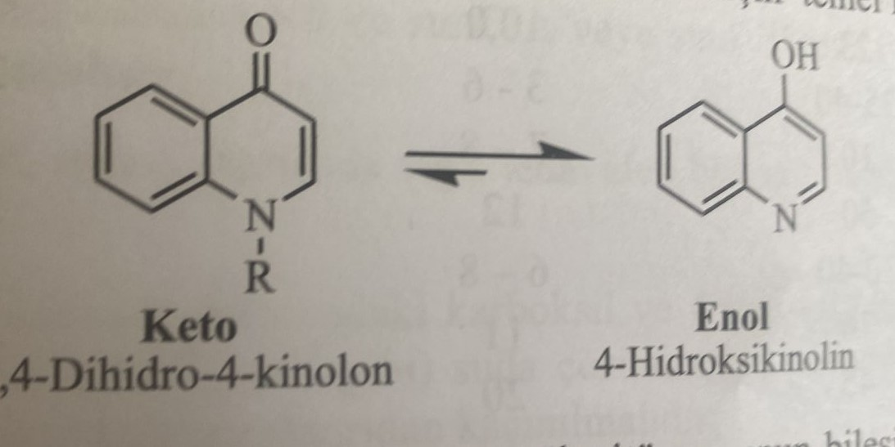
9) Adding a cyclopropyl group instead of an ethyl group in N1 leads to an expansion of the spectrum of activity. As in ofloxacin, steric fixation with a cyclic structure between N1 and C8 improves activity and broadens the spectrum of action.
10) Combination of aromatic functional group such as 2,4-difluorophenyl in N1 increases antibacterial activity. But these derivatives (trovafloxacin and temafloxacin) have serious side effects. As a result of increased lipophilicity, epileptic side effects are observed by passing HEB easily.
The points at which fluoroquinolones interact in biological systems are listed below.
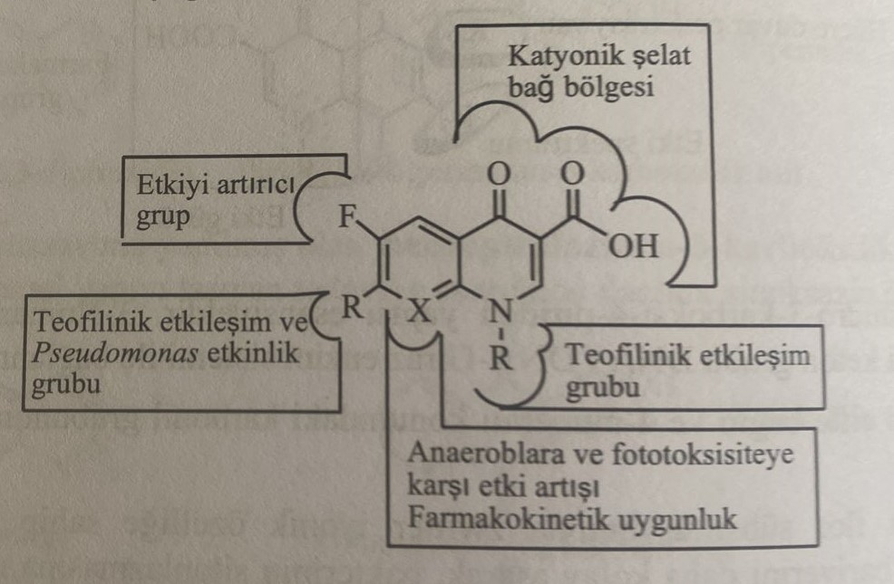
Molecular modifications produce fluoroquinolones from quinolones. These preparations are very suitable for oral application and have good absorption. Compounds that demonstrate optimal properties of the twitter ion are better absorbed. The pharmacokinetic properties of some quinolone derivatives are shown in the table.
As can be seen from the table, the time of elimination of fluoroquinolones from plasma is quite long. The period of half-life of drugs confirms this. They are used for encephalitis and infections of the upper respiratory tract, as they are well tolerated by GEB. Nalidixovaya acid and quinolones of the first generation are used only for infections of the urinary tract. New fluoroquinolones are used for infectious and inflammatory diseases of the respiratory tract.
Modern gyrase inhibitors, fluoroquinolones, are divided into four groups, as shown in the table. These groups are classified according to the spectrum of action, distribution in tissues and mechanisms of resistance formation.
Group I: Compounds of this group are used only for urinary tract infections. Norfloxacin is the prototype compound of the group. It infects Gram(-) bacteria and especially Pseudomonas aeruginosa infections. However, it is poorly distributed in tissues. Pefloxacin (Abactal), an N-methyl derivative of norfloxacin with lipophilic properties, is used in urinary tract infections. Enoxacin obtained later is used for infections of the prostate gland.
Group II: fluoroquinolones of this group (ciprofloxacin, fleroxacin, ofloxacin and levofloxacin) are standard quinolones. They are more effective drugs than the first group. It is used for acute and chronic systemic infections. This is the drug of choice for bronchopulmonary infections, infections resistant to cephalosporins and penicillin allergies. It is used in combination with erythromycin for atypical pneumonia. Levofloxacin and ofloxacin are used in acute osteoarticular infections. Activity is observed in relation to gram(+) infections, such as gram(-) salmonella, enterobacter, hemophilic bacillus.
Group III: fluoroquinolones of this group (grepofloxacin and sparfloxacin) are sensitive to gram (+) bacteria. It is mainly used for mycoplasma and chlamydial infections.
Group IV: clinofloxacin and moxifloxacin belong to this group. At the same time, these drugs penetrate well into the bone tissue, so they are used for the corresponding systemic infections. Nadifloxacin is used for injections of vulgar acne.
The use of compounds of these four groups during pregnancy is contraindicated. It should not be prescribed to children under 15 years of age unless absolutely necessary. Because it causes hemolytic anemia in children. In particular, it is not allowed to be used in deficiency of glucose-6-phosphate dehydrogenase (Fabism). Long-term use causes central side effects and neurotoxicity. Studies have shown that fluoroquinolones cause prolongation of the QT interval. Application is contraindicated to patients with hypokalemia and hypomagnesemia.
Derived 4-quinolone compounds having a carboxyl group in the third position and a ketone group in the fourth position form a chelate with ions Ca2+, Mg2+, Zn2+, Fe2+, Al3+.
Mechanism of action
Quinolones have an antibacterial effect, suppressing the synthesis of bacterial DNA. They show their effects by inhibiting enzymes of bacterial DNA gyrase (topoisomerase II) and topoisomerase IV. These two enzymes, belonging to the class of topoisomerase II, ensure DNA replication and cell division in bacterial cells. In general, gram(-) activity of quinolones is based on inhibition of DNA gyrase, and gram(+) activity is based on inhibition of enzyme topoisomerase IV.
DNA-gyrase is involved in the formation of the superhelical structure of DNA, unwinding and elongation of this structure, as well as indirectly in bacterial replication, transcription and recombination of RNA. Thanks to the super-entangled structure used, it ensures the placement of a DNA chain with a size of 1300 μm and 18.8 x 106 daltons in a bacterial cell with a size of 1 x 2 μm.
DNA-gyrase is a tetrameric enzyme consisting of two subunits A and two subunits B, encoded by genes GyrA and GyrB. Tyrosine in the structure of the enzyme is covalently connected with the phosphate groups of the DNA molecule through the connecting subgroup A of the phenolic hydroxyl group. Quinolones inhibit DNA gyrase by binding to subunit A of the DNA gyrase enzyme in the DNA-forming complex. Thus, the activity of the enzyme is lost. As a result of the binding of quinolones to the enzyme complex and inhibition of the enzyme, bacterial replication does not occur and an antibacterial effect occurs. The DNA becomes too large to fit in the cytoplasm, and the bacterial cell becomes abnormally elongated and explodes.
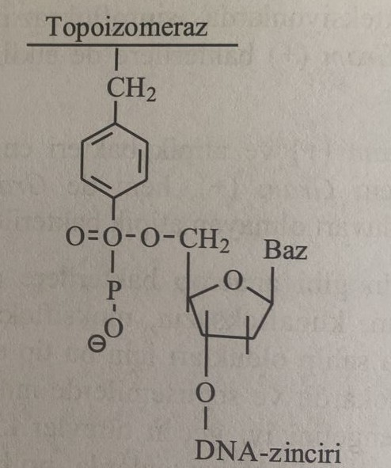
Another target enzyme of quinolones is tropoisomerase IV. Tropoisomerase is a tetrameric enzyme consisting of two ParC subunits and two ParE subunits encoded by ParC and ParE genes. Tropoisomerase IV provides supercoiling of daughter DNA as a result of replication in a dividing bacterial cell. The blockade of this enzyme prevents the twisting of the DNA molecule, which leads to the lysis of bacteria.
Bacterial-selective screening prevented the appearance of these mechanisms in people who have another enzyme, tropoisomerase type II, which shows similarity to DNA-gyrase in bacteria.
Formation of resistance (resistance) of bacteria to quinolones
Bacterial resistance can occur to quinolones, as well as to other antibiotics widely used in clinical and veterinary practice. The mechanisms of bacterial resistance are as follows:
1) Sudden mutation in the genes encoding DNA gyrase and tropoisomerase IV enzymes.
2) Mutation in genes encoding proteins of the efflux pump in the cytoplasmic membrane.
3) Mechanism of antibiotic resistance associated with plasmids
I. Spontaneous mutation in genes encoding DNA gyrase and Topoisomerase IV enzymes
Mutations in genes encoding enzymes-targets of quinolone activity are the main mechanism of antibacterial resistance. Mutations in the genes GyrA and GyrB, which encode the enzyme DNA gyrase, and in the genes ParC and ParE, which encode the enzyme topoisomerase IV, lead to changes in the parts of the enzyme that bind quinolones.
II. Mutations in genes encoding proteins of the efflux pump in the cytoplasmic membrane.
Penetration of some quinolines into the bacterial cell is delayed as a result of mutations in the genes encoding proteins of the outer membrane.
III. Mechanism of plasmid-associated antibacterial resistance
Plasmid-associated resistance to quinolones was first demonstrated in 1998. Using plasmid pmg252 in ciprofloxacin-resistant strains of Klebsiella pneumoniae. Conducted studies have shown that the MPK values for quinolone molecules such as nalidixic acid, norfloxacin, ciprofloxacin, trovafloxacin, where these plasmids can be introduced from different sexes and species by conjugation and gene transfer, increase by 4-16 times.
Epidemiological studies of quinolone resistance were carried out with the discovery of PMQR (plasmid-linked quinolone resistance) genes responsible for quinolone resistance in the Klebsiella pneumoniae strain. Currently, 6 families of genes responsible for resistance to quinolones have been identified. These genes are Qnr qnrA, qnrB, qnrC, qnr
D represents qnrS and qnrVC. These genes encode genes of pentapeptide repeats that protect tropoisomerase type II of bacteria from the action of quinolone compounds and cause bacterial resistance to quinolones. In the conducted studies, the gene qnrE1 was identified in PCR-tests conducted on the Klebsiella pneumoniae strain.
Biotransformation in quinolones
A metabolite of 3,7-biscarbonic acid is found in the urine, which is formed during the oxidation of the methyl group in the seventh position of nalidixic acid. This metabolite has an antibacterial effect.
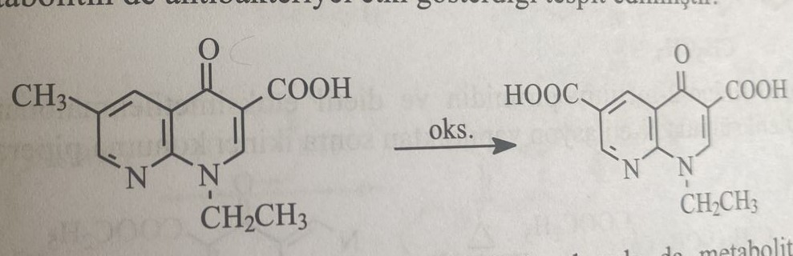
Second-generation fluoroquinolones form metabolites participating in phase II reactions, as well as phase 1 reactions. In the seventh case, enoxacin is selected, which retains the 4-methylpiperazine group, and in the third case, a phase II metabolite is immediately formed from the conjugation of the carboxyl group with glucuronic acid, and piperazine- 4-methyl Metabolite -N-oxide is formed by N-oxidation followed by N-demethylation and re-oxidation, resulting in a metabolite of piperazine-3-oxide. These phase I metabolites form phase II metabolites with sulfate and formate conjugates. In general, metabolites formed during dealkylation of the first state are very rare.
10-12% of ciprofloxacin and 15% of enoxacin undergo metabolism. This shows that this group of antibacterial compounds is excreted unchanged in the urine. With this purpose, it is used as a drug for urinary infections.
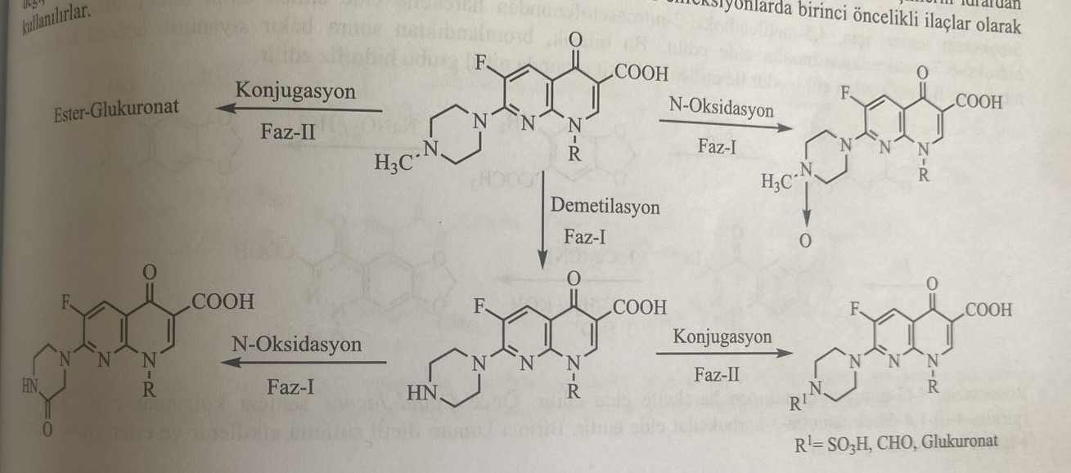
2-amino-6-methylpyridine is used as a starting material for the synthesis of nalidixic acid. This compound interacts with diethylethoxymethylenemalonate to form a 1,8-naphthyridine ring. After the alkylation of the first state, the ester group is hydrolyzed by ethyl iodide. This reaction is carried out by the closing of the ring of 4-pyridone-3-carboxylic acid (Could-Jacobs reaction).
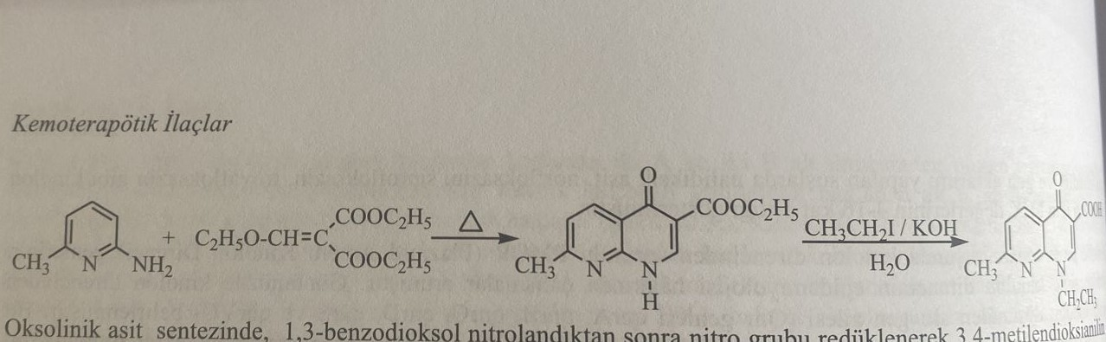
In the synthesis of oxolinic acid, after 1,3-benzodioxol is nitrated, the nitro group is reduced and 3,4-methylenedioxyaniline is obtained. 1,4-dihydro-4-pyridone-3-carboxylic acid is obtained with diethyl ethoxymethylenemalonate. Then an ethyl group is introduced into the first position with ethyl iodide.
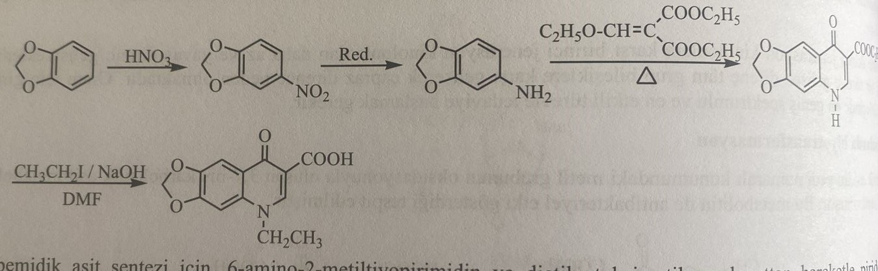
6-amino-2-methylthiopyrimidine and diethyl ethoxymethylenemalonate are used for the synthesis of pipemidine acid. Pyrido[2,3-d] pyrimidine is obtained. After N-ethylation with diethyl sulfate, piperazine is added to the second position.
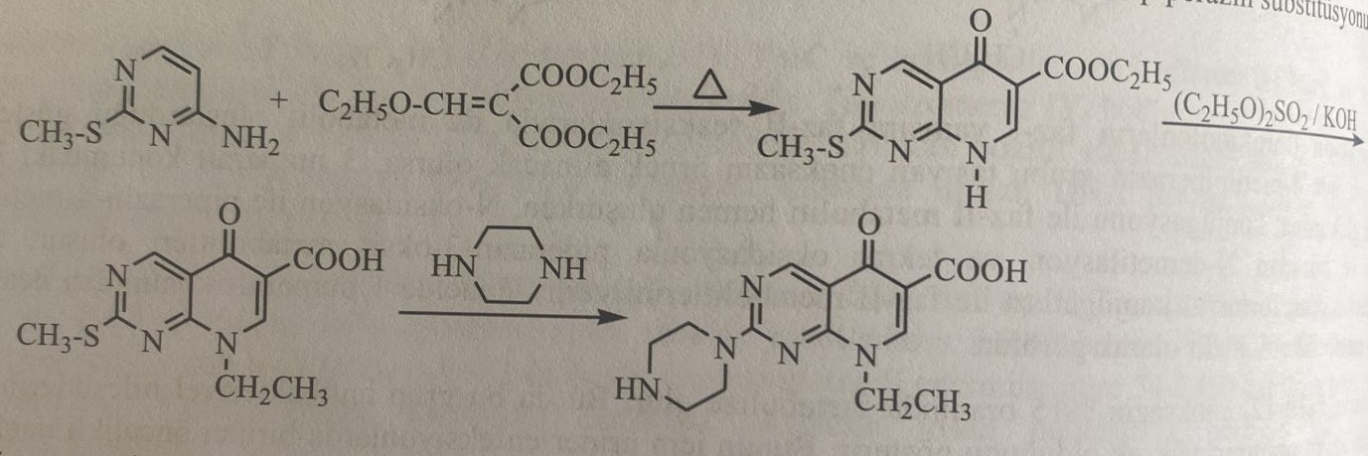
For the synthesis of sinoxacin, 4,5-methylenedioxy-2-nitroacetaphenone is used as an amine derivative, and 4-hydroxy-6,7-methylenedioxycinnoline is obtained by diazotization. After bromination of this compound, nitrilation is carried out in the third position with copper cyanide. In the first case, ethyl is ethylated with iodide and the nitrile group is hydrolyzed in acidic medium.
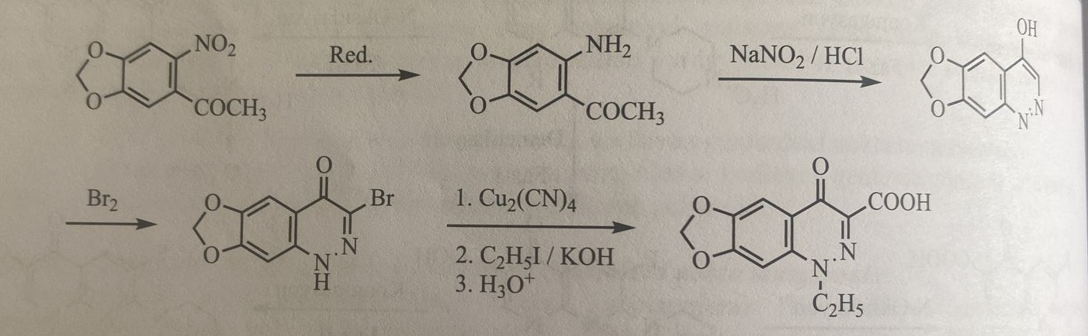
Rosoxacin is obtained using 4-(3-nitrophenyl)pyridine. The first Could-Jacobs reaction gives ethyl 4-oxo-7-(pyridin-4-yl)-1,4-dihydroxyquinoline-3-carboxylic acid. In the first case, it is alkylated with diethyl sulfate and the ester group is hydrolyzed.
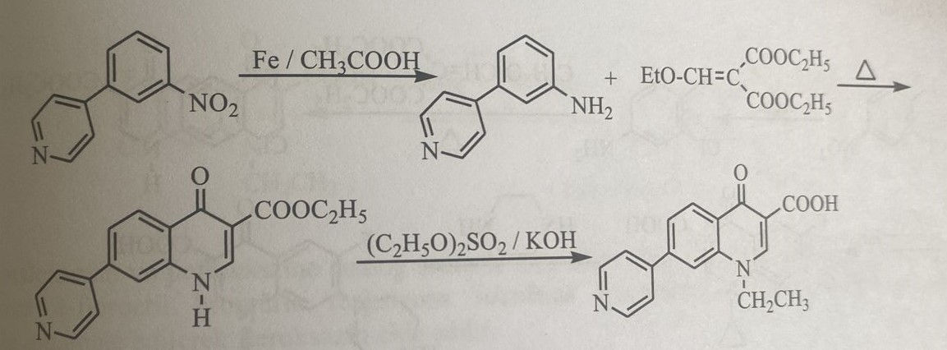
3-chloro-4-fluoroaniline is used as a starting material for the synthesis of norfloxacin. Ethyl 6-fluoro-7-chloro-4-oxo-1,4-dihydroxynoline-3-carboxylic acid is synthesized by performing the Could-Jacobs reaction. The first state is alkylated with ethyl bromide. A piperazine ring is then attached to the seventh position.
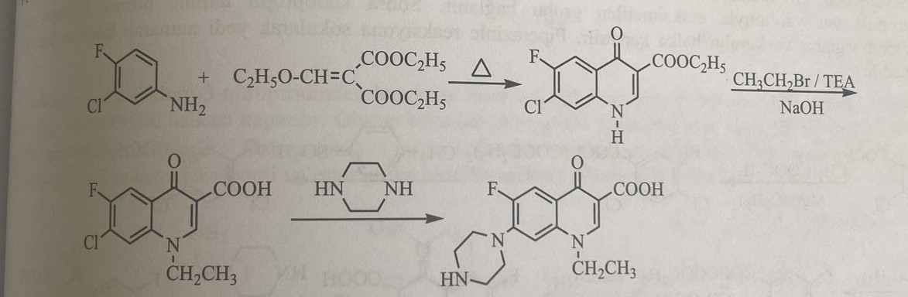
2-hydroxy-3,4-difluoronitrobenzene is synthesized using 2,3,4-trifluoronitrobenzene for the synthesis of ofloxacin. The phenoxy group combines with monochloroacetone, and the nitro group is restored to form a 1,4-benzoxazine ring. Reaction Jacobs after obtaining 1-methylpiperazine and 1-methylpiperazine in the tenth position. When obtaining levofloxacin, the levoisomer of the compound, after obtaining the derivative 1,4-benzoxazine, the isomers are separated using D-camphonsulfonic acid or D-dibenzoyltartrate acid. Then apply the synthesis analogously to ofloxacin.
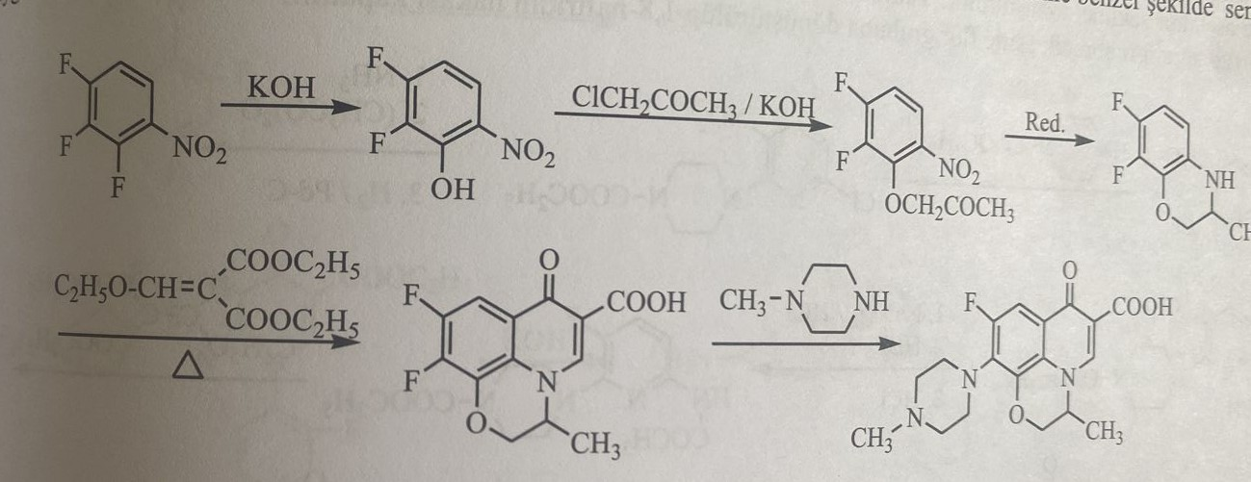
The synthesis of ciprofloxacin is carried out by many different methods. One of them is similar to the synthesis method of norfloxacin. The quinolone ring is closed and after first-state ethylation, cyclopropylation is performed.
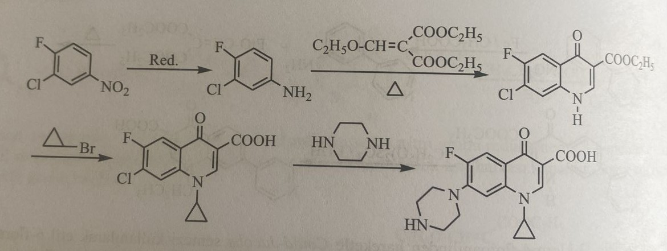
The preparation can also be obtained using 2,4-Dichloro-5-fluorobenzoyl chloride. This is the Bayer method. The compound is first condensed with ethoxymethylenediethyl malonate to give ethyl 2,4-dichloro-5-fluorobenzoyl acetate. Ethoxymethylene is added to this structure with the help of triethoxyformate acid. Then the amine group is attached to the first position with cyclopropylamine and the quinoline ring is closed. By reacting with piperazine, it is coupled to the seventh position.
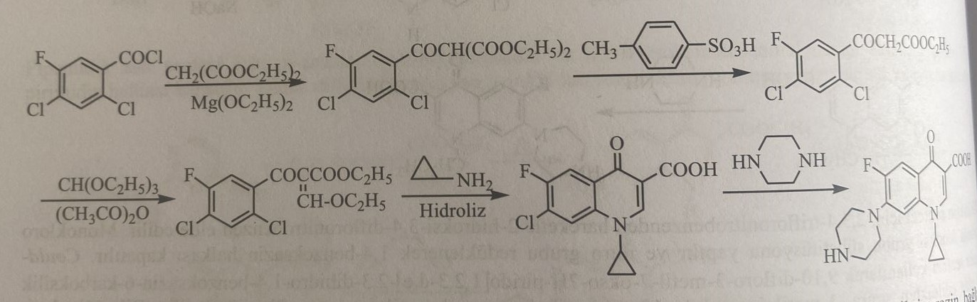
Enoxacin is synthesized in the presence of 2,6-dichloro-3-nitropyridine. N-ethoxycarbonylpiperazine is added to the first molecule, then the Could-Jacobs reaction is performed. A naphthyridine ring is obtained. The acetamide form is obtained with chlorine in the sixth position, ammonia and acetic anhydride. Then, in the third position, the nitro group is reduced. The amine group is diazotized, tetrafluoroborane acid is converted into fluorine, and the 1,8-naphthyridine ring is closed.
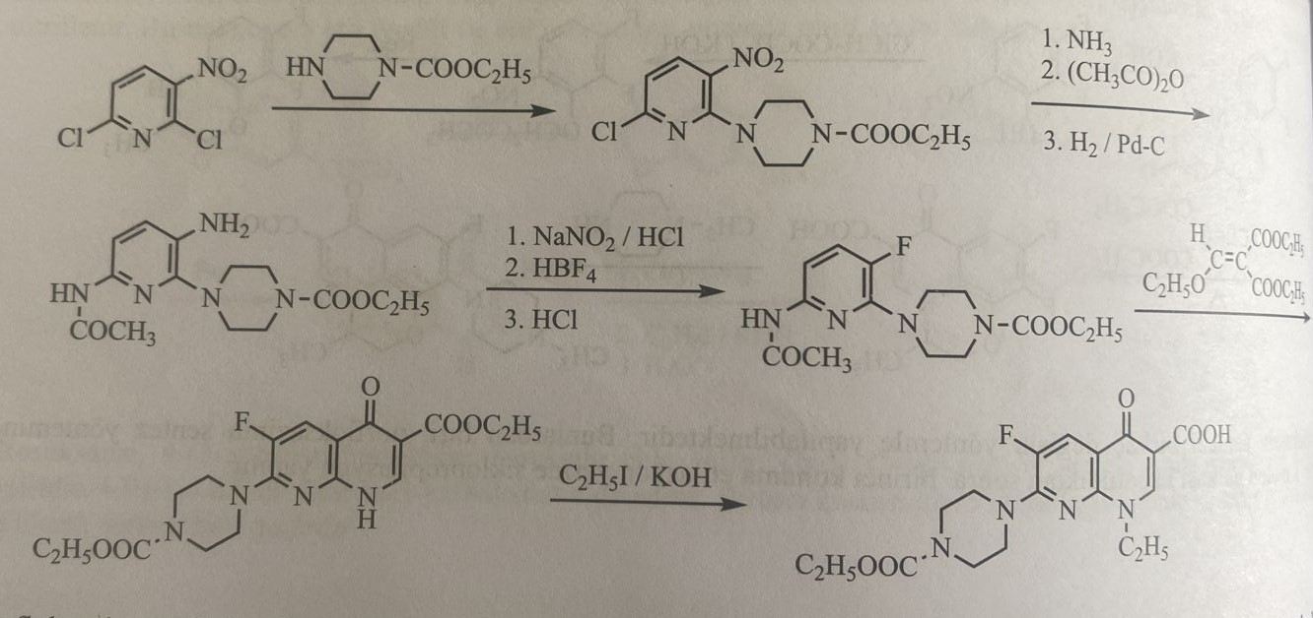
The synthesis of pefloxacin is as follows:
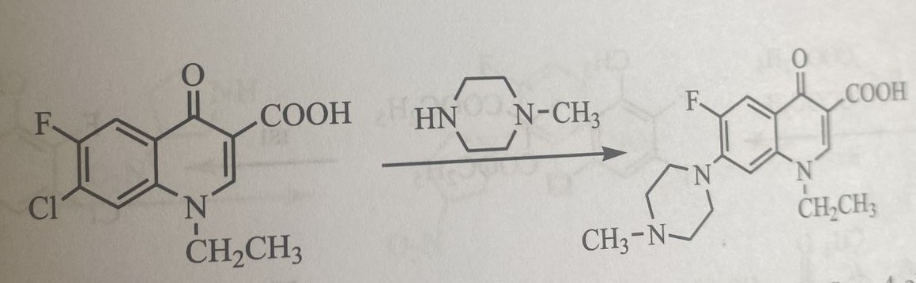
Synthesis of fleroxacin
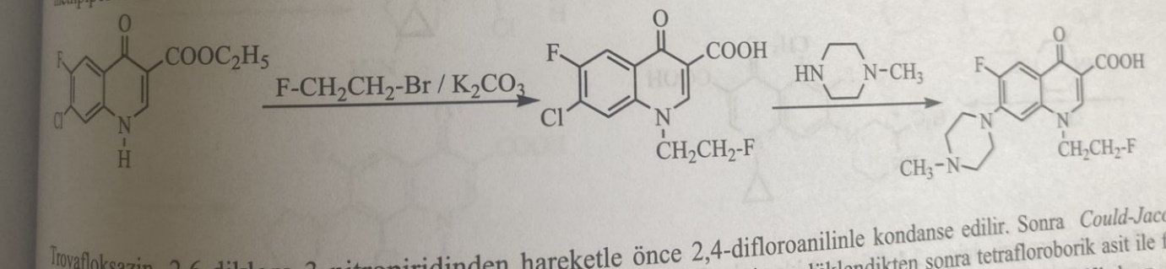
Synthesis of trovafloxacin
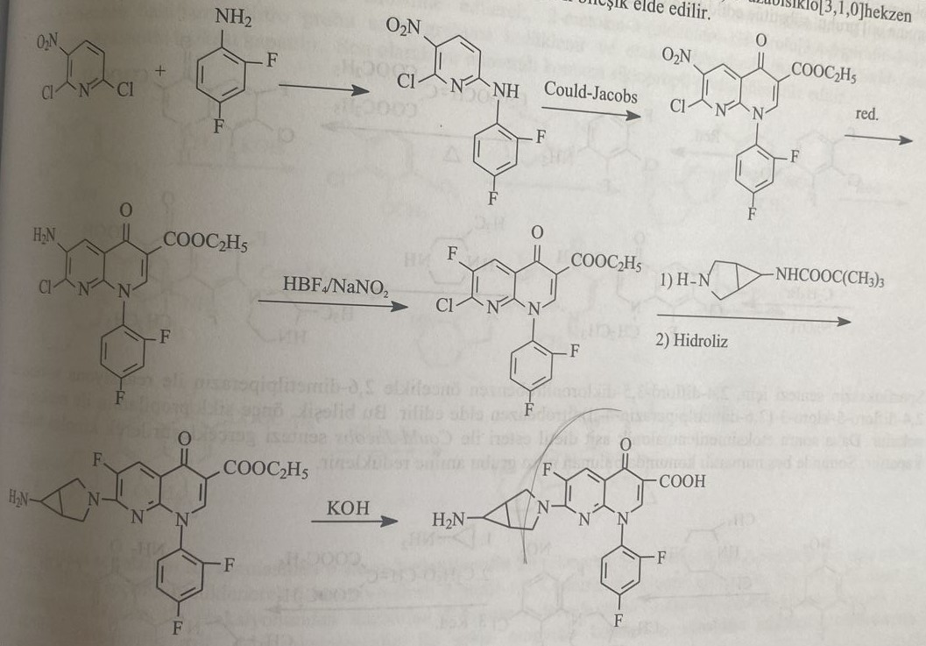
Synthesis of grepafloxacin
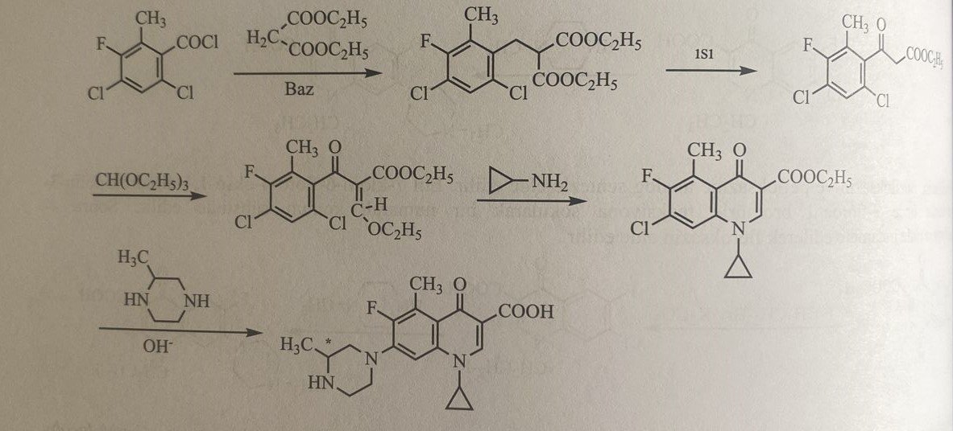
Synthesis of lomefloxacin
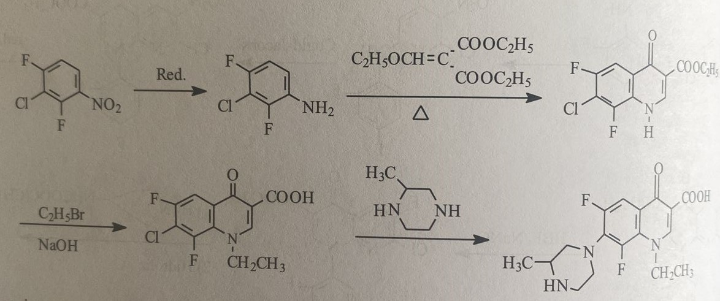
Synthesis of sparfloxacin
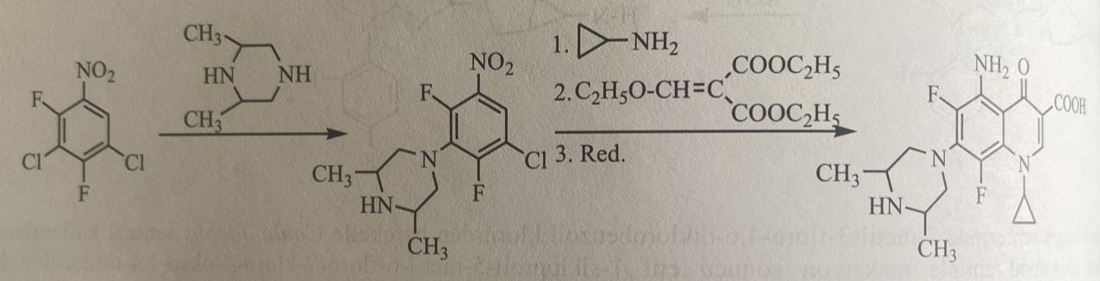
Synthesis of clinofloxacin
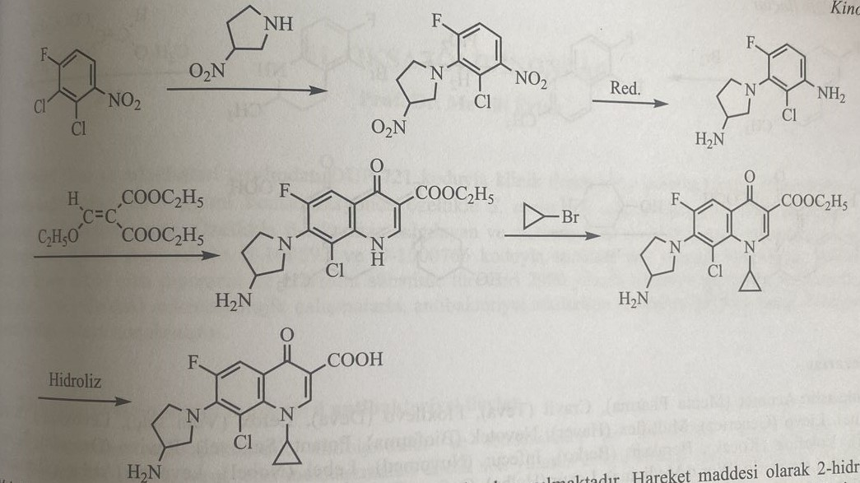
Synthesis of moxifloxacin
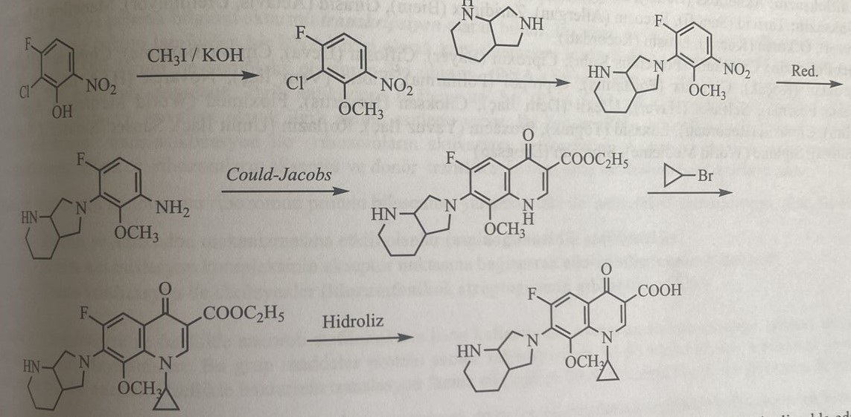
Synthesis of nadifloxacin
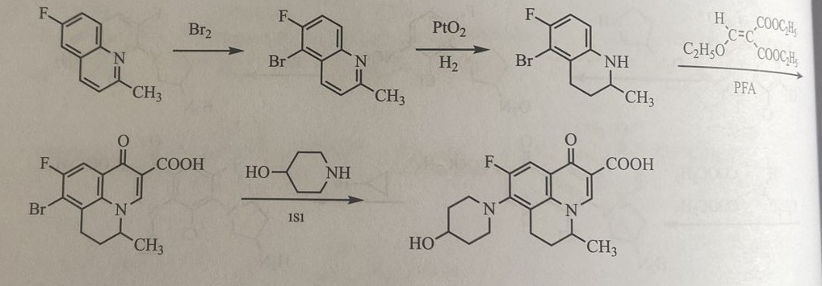
Oxazolidinone
In recent years, Slee and his colleagues entered clinical trials under the code number DUP-721, which has a structure based on oxazolidinone in a concentration of 0.5-4 μl/ml. A certain bactericidal effect, especially in beta-lactamase-secreting and methicillin-resistant strains. In clinical experiments, highly resistant strains of staphylococci and streptococci with code U-100592 and U-1000766 are effective. Combined derivatives of piperazine and morpholine were included in treatment under the names of eperozolid and linezolid in 2000. In recent years, microbiological studies have established that its antibacterial effects are based on the inhibition of the synthesis of ribosomal proteins.
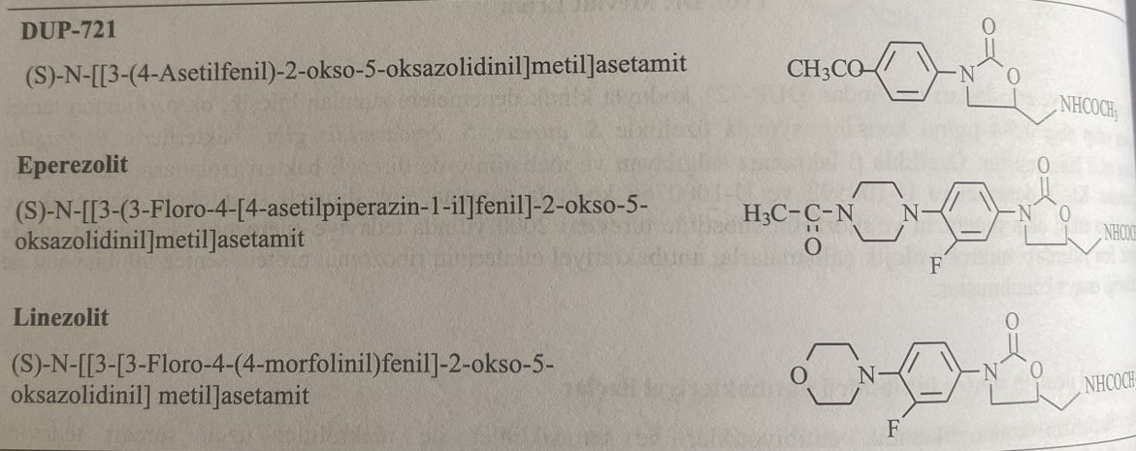
Ribosomal protein synthesis inhibitors Antibacterial preparations
Antibiotics of the aminoglycoside series, as well as tetracyclines and macrolides of this group of preparations, have long been used in treatment. The mechanism of action of these preparations was revealed in recent years. Inhibition of small 30S and large 50S subunits of bacterial ribosomal synthetase leads to an antibacterial effect. The formation of both subgroups occurs from different ribosomal RNAs and proteins. They are called ribonucleoproteins. The structure of human and bacterial ribosomes is different.
The transfer of genetic information from DNA to RNA is called transcription. This event represents the copying of the sequence of nucleotides that make up DNA into the sequence of RNA by the enzyme RNA polymerase. This happens in the cytoplasm of the cell. This formation initiates the synthesis of transport RNA. Here it is collected in section 30S. It binds to a related anticodon. This bond is covalently formed by amino acids. Trans-cyclization of an amino acid peptide chain connecting two neighboring RNA molecules forms ribosome activation centers. This is called a peptidyltransferase center. Thus, the inhibitory properties of ribosomes due to acceptor and donor translocation are manifested.
Inhibition of protein synthesis leads to anti-infective activity due to competitive action on ribosomal protein synthesis. This is:
1) Effective codon and anticodon mechanisms (aminoglycosides)
2) those that bind to the acceptor point of the RNA initiation complex (oxazolidinones)
3) Agents of transcyclization (chloramphenicol, streptogramin)
Synthesis DUP-721
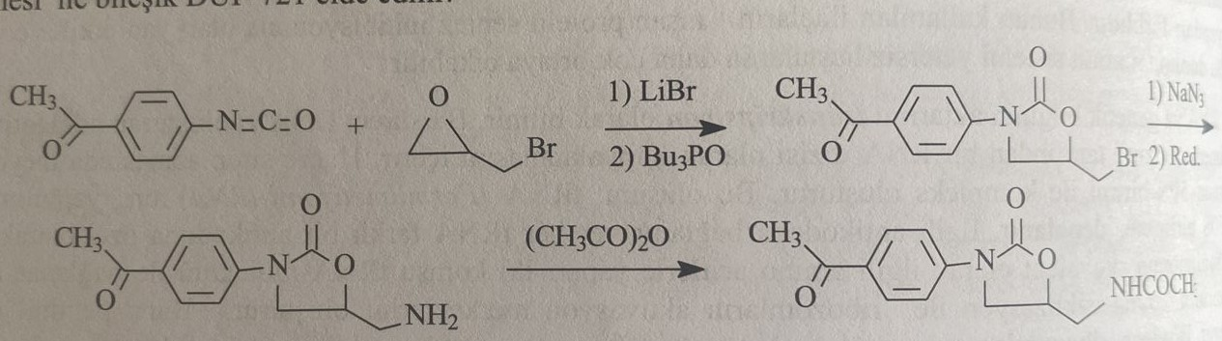
Synthesis of eperozolid and linezolid
